|<

<component / system>

Functional Specification (FS)

Journal: Functional Specification (FS).docx

Date: <date>

Revision: <revision>

Pages: 16

Initials: <INI>

|  |
| --- |
| © BEUMER Group 2018  This document and all data contained herein are the exclusive intellectual property rights of BEUMER Group and are supplied in strictest confidence under the express condition that any reproduction, transmission, transcription etc., or storing in any retrieval system/form, or any kind of supply to others is strictly forbidden without express prior written consent. The receiver guarantees that any disclosed material shall not be used in any way detrimental to the interest of BEUMER Group. |

|<

Contents

Page

1. revisions 4

2. Introduction 5

2.1 About This Document 5

2.2 Target group 5

2.3 Terminology 5

2.4 References 6

2.4.1 External interfaces 6

3. <component/system> Overview 7

3.1 Operational concepts and scenarios 7

3.2 Requirement identification 7

3.3 GUI examples 8

4. Functional overview 9

4.1 Functional group 1 9

4.1.1 Function 1.1 9

4.1.2 Function 1.2 10

4.2 Functional group 2 10

4.2.1 Function 2.1 10

4.2.2 Function 2.2 10

4.3 Functional group 3 10

5. Interfaces 11

5.1 Interface 1 11

5.1.1 Interface function 1.1 11

5.1.2 Interface function 1.2 11

5.2 Interface 2 11

6. Resource supervision and housekeeping 12

6.1 <Housekeeping> 12

6.2 <Ressource Supervision> 12

6.3 <Interface Supervision> 12

6.4 <Alarm Presentation> 12

7. Operational configuration 13

8. <Statistics> 14

9. <component/system> characteristics 15

10. Requirement identification index 16

# revisions

| Rev | Date | Init. | Description |
| --- | --- | --- | --- |
| 0.1 |  |  | Initial revision |

# Introduction

<This document is a template for a Functional Specification (FS) document. The FS document forms part of the BDK software development process, outlining the functionality of the component/system being described and linking it with requirement ID.>

<Guiding template text is stated in blue colour.>

<***Example text is stated as italic text in blue colour***.>

<Provide here an introduction text for the component/system being described.>

## About This Document

<Describe the content of this document; what is explicitly contained and what is outside the scope of this document.>

<***This document specifies the functions of the XXX in the YYY:***

* ***The XXX application***
* ***The sortation modules***
* ***The YYY application***

***The ZZZ forming part of the solution is not described in this document, as it will be elaborated on in the QQQ specification.***>

## Target group

<Describe the intended audience of this document. Also describe which prerequisites apply for the audience.>

***<This document is intended for end-users and external partners in order for them to get a detailed view of the function of the XXX. It is presumed that the reader has basic understanding of YYY.>***

## Terminology

This section contains a list of definitions and explanations of terms used throughout the document.

| **Term** | **Description** |
| --- | --- |
| <term/acronym> | <description> |
|  |  |

## References

This section contains a list of documents referred to in this FS.

| **Reference** | **Document identification** |
| --- | --- |
| <[ref_id]> | <reference text, e.g. document header> |
| [ref_id] |  |

### External interfaces

This section contains a list of documents referred to in this FS, which are related to the external interfaces of <component/system>.

| **Reference** | **Document identification** |
| --- | --- |
| <[ref_id]> | <reference text, e.g. document header> |
| [ref_id] |  |

# <component/system> Overview

<Provide an overview of the component/system being described in the FS. If applicable make sure to place the component/system in context, i.e. show its immediate surroundings.>

***<The BHS is modularly structured and consists of multiple subsystems. Figure 2‑2 illustrates the BHS subsystems and how they communicate with each other.***



***Figure 2‑2 - Deployment of the BHS controls***

***The BHS controls are built by the set of applications and modules described below.***

***The SAC application …>***

## Operational concepts and scenarios

## Requirement identification

Throughout this document IDs used for requirement tracking are specified as ’**ID:** *a.b.c*’. The requirements use a dot notation and are hierarchically structured; e.g.:

**ID**: <*a.b.c>*

***<ID: csc.ItemHandling.ItemScanned***

***Here ‘csc’ means that it is a requirement to the CSC, ‘ItemHandling' means that the requirement is related to general item handling and 'ItemScanned' that the requirement is related to scanning an item. Other requirements may exist under the ‘ItemScanned’ level, like:***

***ID: csc.ItemHandling.ItemScanned.OnSorter***

***>***

Words/abbreviations are used as requirement IDs as words are easier to memorise than e.g. numbers.

Some sections begin with an introductory passage, however the introduction is not regarded as a requirement. All requirements are prefixed with an ID.

## GUI examples

***<The document contains various GUI examples from applications. The examples are provided to assist the perception of a given function or subsystem and may differ from the final dialogues of the GUI as to layout of components, fields and buttons.>***

# Functional overview

<Describe the functionality of the component/system. For large systems it may be useful to split the description of functions into meaningful groups, allowing the reader to browse through the group descriptions before diving into explicit function details.>

***<This section describes the functionality of the XXX. The description is split in functional groups:***

* ***Group 1***
* ***Group 2***
* ***Group 3***
* ***…***

***Each functional group will be described on high level, before a more thorough description is provided for individual functions within the group.>***

## Functional group 1

<Describe the overall purpose/functionality of the functional group. If relevant, briefly describe how it relates to other functional groups and/or the surroundings.>

### Function 1.1

<Describe in more detail the purpose/functionality of this function.>

<Requirement IDs are inserted like this:

1. A unique identifier reflecting the requirement (functional / non-functional) is decided, as specified in 3.1.1
2. Remember to pre-pad the ID with a bold text and a colon (**ID**:)
3. Mark the identifier and select **References** → **Mark Entry**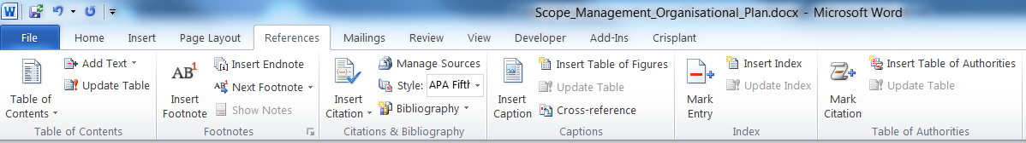
4. On the Mark Index Entry Pop-up press button **Mark**  
   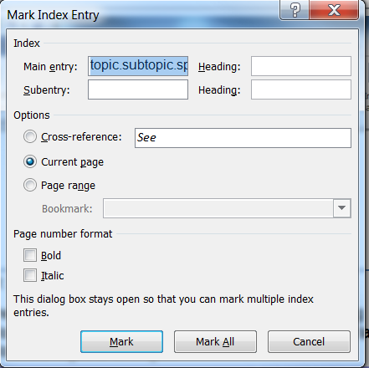
5. Word will now insert a hidden field tagging the requirement>

<To view and edit the actual requirement ID, use the **Home** → **¶** to view hidden text.>

**ID**: aaa.bbb.ccc

### Function 1.2

<Describe in more detail the purpose/functionality of this function.>

## Functional group 2

### Function 2.1

### Function 2.2

## Functional group 3

# Interfaces

<Describe the interfaces of the component/system.>

## Interface 1

<Describe the overall purpose/functionality of the interface.>

### Interface function 1.1

<Describe in more detail the purpose/functionality of this function>

### Interface function 1.2

<Describe in more detail the purpose/functionality of this function>

## Interface 2

# Resource supervision and housekeeping

<If applicable, describe which kind of supervision/monitoring functionality is built into the component/system, and which kind of automatic housekeeping functionality exists.>

## <Housekeeping>

## <Ressource Supervision>

## <Interface Supervision>

## <Alarm Presentation>

# Operational configuration

<Describe the configuration that the operators can change in order to configure the component/system as required for its operation.>

# <Statistics>

<Describe the statistics attributes (e.g. KPI) that is provided by the component/system.>

# <component/system> characteristics

<Describe any operational characteristics that apply for the component/system. This can be e.g. maximum load, response time, number of users etc.>

# Requirement identification index

<If the requirement IDs are inserted correctly in the document, it is possible to automatically generate a complete list of IDs in the table below.>

aaa.bbb.ccc 13